Discovery report

Fabjan Teja and Mihelčič Matej

Abstract: New faint EW variable star in constellation Draco

Star name and V mag | N2IG027657 (GSC2.3) | V = 16.41
RA and DEC (J2000) | 20 08 55.024 | +52 32 08.5
Num. observations, nights | 514 | 3 nights
Amplitude (mag) | 0.620
Var. type | EW
Period (day) | 0.350890
Epoch HJD | 2455377.377969
Telescope | 25-cm f/2.6 + R band + ST-7XME
Location | Ljubljana, Slovenia
Fig. 1: Reference CCD frame / Finding chart
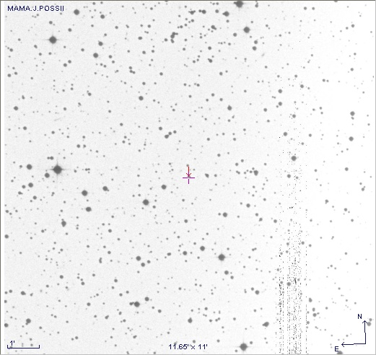
Fig. 2: Light curves
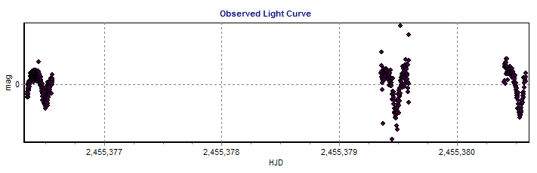
Fig. 3: Phase diagram

