Observation of a suspected flare in a dMe star.

During a routine ccd observation of V879 AQL last november, 8 2007 a field star showed a strong luminosity variation of about 1 magnitude.
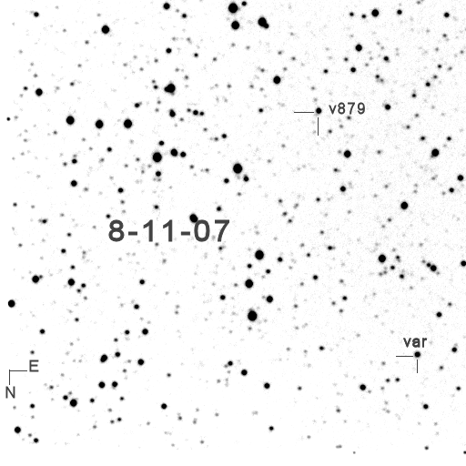
Figura 1: var is the suspected flare star
The following figure shows the luminosity variation in V as difference respect to the comp star band TYC 1030 3102.
Next figure shows differences v-c and c-k. Check star is GSC 1030 3070.
I sent these data to AAVSO director, Arne Henden, that suggested an identification with UCAC2 35802161 object, at J2000.0 coordinates 18:50:08.900 +11:05:09.98, of V magnitude 13.81 and with an index color B-R of about 1.8 (GSC 2.2) and with a large proper motion.

On the basis of these informations dr. Henden concluded that:
“this looks like a red variable. The light curve you showed looked like a typical flare from a red dwarf (dMe),and the proper motion is shown as being pretty large (which would also imply a close distance). I think this is a dMe flare star.”

From that time, i’m monitoring the star in search of new flares.

All observations were done with a 40 cm f/7.3 Ritchey-Chretien telescope, a Sbig ST9E ccd camera and a Johnson V filter. Software used: Muniwin.

Marzio Rivera
Casasco Astronomical Observatory

Italy

m.rivera@astroambiente.org

