**Finding chart and information**

**KAO-EGYPT J225702.44+523222.1**

**Report Date:**30/10/2016  
  
**Observers and affiliation:**

A. Shokry; M. Eldepsy; S. Saad; M. Darwish and I. Zead

National Research Institute of Astronomy and Geophysics (NRIAG)

Astronomy Department, Kottamia Observatory, 1.88 cm reflector telescope Helwan, Cairo, Egypt

E.mail:

[ahmedsh_11@yahoo.com](mailto:ahmedsh_11@yahoo.com); saadmhsaad@gmail.com; [darwish.msk@Gmail](mailto:darwish.msk@Gmail); m_deps2000@yahoo.com

; z_ibrahim_zead@yahoo.com

1. **Observations**

The photometric observations were carried out over two nights (8 October 2016) using the CCD Camera with format 2048×2048 pixels attached to Kottamia 1.8 m telescope (Egypt) in Newtonian focus.

The new discovered variable KAO-EGYPT J225702.44+523222.1

has been observed in different basebands and the variability was very clear as an eclipsing binary system. table :1 represent coordinates and magnitude of variable and comparison stars, while figure 1 shows the chart of the new discovered variable star and comparison.

Table 1: Coordinates and magnitude of variable and comparison stars

|  |  |  |  |  |
| --- | --- | --- | --- | --- |
| Object | R.A | Dec | Vmag(Max) | Vmag(Min) |
| V (KAO-EGYPT J225702.44+523222.1) | 22 57 02.435 | +52 32 22.13 | 14.13 | 14.65 |
| Comp(2MASS J22565686+5232325) | 22 56 56.862 | +52 32 32.50 | 15.5 |  |

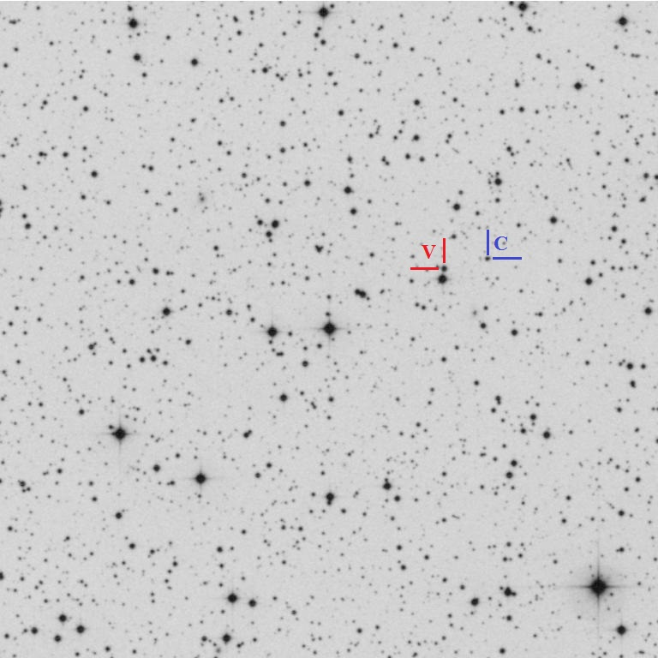

Figure 1:The new discovered variable star (V) KAO-EGYPT J225702.44+523222.1 and the coparison star (C) 2MASS J22565686+5232325.

**2- Data reduction**

Reduction done by using MUNIWIN (Motl, 2011) differential photometry has been done for star KAO-EGYPT J225702.44+523222.1 by using 2MASS J22565686+5232325 as comparison star.

**3- Period and time of minimum of new variable star**

The time of minimum was determined from the primary and secondary eclipses using the method of kwee and van Woerden (1956), while period of the star determined using method of Nelson (2006). Ephemeris of the new discovered variable star is shown in table 2.

Table 2: Ephemeris of new discovered variable star

|  |  |  |
| --- | --- | --- |
| Object | period(day) | Epoch(Min I) |
| UCAC4 713-110148  USNO-A2.0 1425-14338940  2MASS J22570242+5232220 | 0.273553 | 2457670.30200±0.00018 |

Using ephemeris from table 2 we determine the epoch of the star by eq (1), hence the phase magnitude relation has been illustrated in Fig (2). the phase magnitude table values are shown in table 3

**HJD.(Min.I) = 2457670.30200±0.00018+0.273553× E (1)**

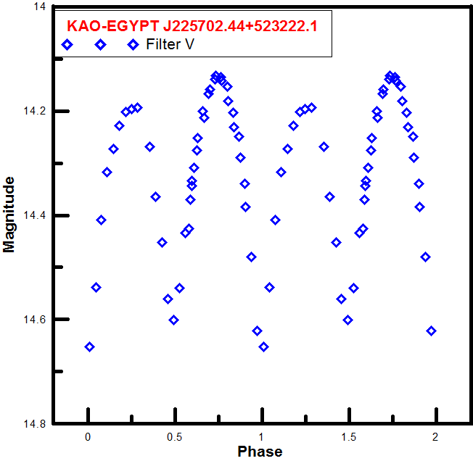

Figure 2: phase& magnitude relation for the variable star KAO-EGYPT J225702.44+523222.1 in filter V.

Table 3 Observations of the variable star KAO-EGYPT J225702.44+523222.1 in filter V.

|  |  |
| --- | --- |
| Phase | V Mag |
| 0.5796061 | 14.42506 |
| 0.5869173 | 14.36963 |
| 0.5942285 | 14.34413 |
| 0.6088509 | 14.30834 |
| 0.6271289 | 14.2756 |
| 0.6600293 | 14.19976 |
| 0.6929297 | 14.16762 |
| 0.7294857 | 14.13902 |
| 0.7623861 | 14.13452 |
| 0.7989421 | 14.15295 |
| 0.8318425 | 14.20368 |
| 0.8683984 | 14.24892 |
| 0.9012988 | 14.33899 |
| 0.9378548 | 14.48013 |
| 0.9707552 | 14.62196 |
| 0.0073112 | 14.65286 |
| 0.0438672 | 14.53806 |
| 0.0767676 | 14.4091 |
| 0.109668 | 14.31747 |
| 0.1462239 | 14.27242 |
| 0.1791243 | 14.22773 |
| 0.2156803 | 14.20214 |
| 0.2485807 | 14.19615 |
| 0.2851367 | 14.19403 |
| 0.3545931 | 14.26846 |
| 0.3874935 | 14.36439 |
| 0.4240495 | 14.45242 |
| 0.4569498 | 14.56042 |
| 0.4935058 | 14.60056 |
| 0.5264062 | 14.54023 |
| 0.5593066 | 14.43348 |
| 0.5958626 | 14.33436 |
| 0.628763 | 14.25249 |
| 0.665319 | 14.21259 |
| 0.6982194 | 14.1586 |
| 0.7347753 | 14.13251 |
| 0.7676757 | 14.1414 |
| 0.8042317 | 14.18091 |
| 0.8371321 | 14.23117 |
| 0.8736881 | 14.28892 |