**Finding chart and information**

**KAO-EGYPT J231639.27+595223.04**

**Report Date:** 11/09/2017  
  
**Observers and affiliation:**

M.S. Darwish; I. Zead; S.M. Saad and M. Eldepsy

National Research Institute of Astronomy and Geophysics (NRIAG)

Astronomy Department, Kottamia Observatory, 1.88 cm reflector telescope Helwan, Cairo, Egypt

E.mail:

[darwish.msk@gmail](mailto:darwish.msk@gmail); saadmhsaad@gmail.com; z_ibrahim_zead@yahoo.com

1. **Observations**

The photometric observations were carried out over three nights (18&19&20 August 2017) using the CCD Camera with format 2048×2048 pixels attached to Kottamia 1.8 m telescope (Egypt) in Newtonian focus.

The new discovered variable KAO-EGYPT J231639.27+595223.04 has been observed in different basebands and the variability was very clear as an eclipsing binary system. table :1 represent coordinates and magnitude of variable and comparison stars, while figure 1 shows the chart of the new discovered variable star and comparison.

Table 1: Coordinates and magnitude of variable and comparison stars

|  |  |  |  |  |
| --- | --- | --- | --- | --- |
| Object | R.A | Dec | I mag (Max) | I mag (Min) |
| V (KAO-EGYPT J231639.27+595223.04) | 23 16 39.269 | +59 52 23.04 | 14.93 | 15.40 |
| Comp(UCAC4 750-081392) | 23 16 28.92 | +59 52 40.36 | 14.20 |  |

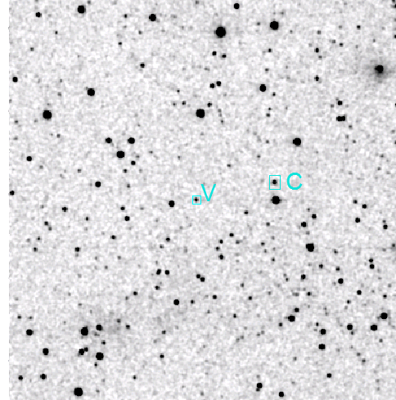

Figure 1: The new discovered variable star (V) KAO-EGYPT J231639.27+595223.04 and the comparison star (C) UCAC4 750-081392.

**2- Data reduction**

Reduction done by using MUNIWIN (Motl, 2011) differential photometry has been done for the star KAO-EGYPT J231639.27+595223.04 by using

UCAC4 750-081392 as a comparison star.

**3- Period and time of minimum of new variable star**

The time of minimum was determined from the primary and secondary eclipses using the method of Kwee and van Woerden (1956), while period of the star determined using method of Nelson (2006). Ephemeris of the new discovered variable star is shown in table 2.

Table 2: Ephemeris of new discovered variable star

|  |  |  |
| --- | --- | --- |
| Object | period(day) | Epoch(Min I) |
| V (KAO-EGYPT J231639.27+595223.04)  UCAC4 750-081424  2MASS J23163926+5952229 | 0.3765 | 2457984.59018 ± 0.0001 |

Using ephemeris from table 2 we determine the epoch of the star by eq (1), hence the phase magnitude relation has been illustrated in Fig (2). The phase magnitude table values are shown in table 3.

**HJD.(Min.I) = 2457984.59018 ± 0.0001+** **0.3765 × E (1)**

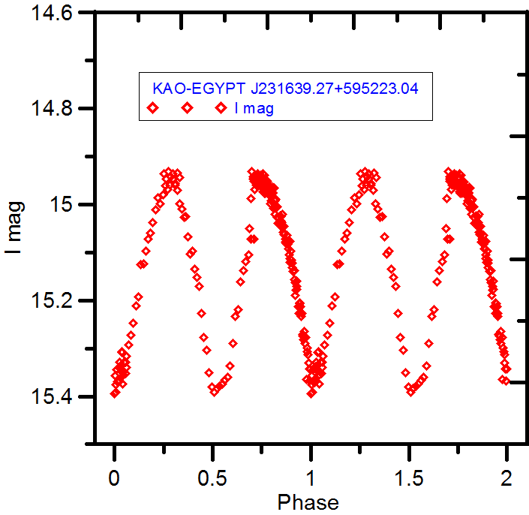

Figure 2: phase& magnitude relation for the variable star KAO-EGYPT J231639.27+595223.04 in filter I.

Table 3 Observations of the variable star KAO-EGYPT J231639.27+595223.04 in filter I.

|  |  |
| --- | --- |
| HJD | I mag. |
| 2457986.358 | 14.987 |
| 2457986.362 | 14.942 |
| 2457986.367 | 14.941 |
| 2457986.371 | 14.956 |
| 2457986.376 | 14.939 |
| 2457986.381 | 14.936 |
| 2457986.385 | 14.963 |
| 2457986.390 | 14.953 |
| 2457986.395 | 14.974 |
| 2457986.399 | 14.977 |
| 2457986.404 | 14.991 |
| 2457986.409 | 15.005 |
| 2457986.413 | 15.024 |
| 2457986.418 | 15.021 |
| 2457986.423 | 15.061 |
| 2457986.427 | 15.064 |
| 2457986.432 | 15.076 |
| 2457986.437 | 15.122 |
| 2457986.441 | 15.138 |
| 2457986.446 | 15.159 |
| 2457986.451 | 15.206 |
| 2457986.455 | 15.228 |
| 2457986.460 | 15.265 |
| 2457986.484 | 15.343 |
| 2457986.486 | 15.348 |
| 2457986.490 | 15.349 |
| 2457986.495 | 15.340 |
| 2457986.500 | 15.293 |
| 2457986.504 | 15.272 |
| 2457986.509 | 15.248 |
| 2457986.514 | 15.211 |
| 2457986.518 | 15.192 |
| 2457986.523 | 15.125 |
| 2457986.528 | 15.123 |
| 2457986.532 | 15.097 |
| 2457986.537 | 15.072 |
| 2457986.542 | 15.059 |
| 2457986.547 | 15.038 |
| 2457986.551 | 15.011 |
| 2457986.556 | 14.987 |
| 2457986.561 | 14.998 |
| 2457986.565 | 14.980 |
| 2457986.570 | 14.960 |
| 2457986.575 | 14.968 |
| 2457986.579 | 14.960 |
| 2457986.584 | 14.935 |
| 2457986.589 | 14.956 |
| 2457986.593 | 14.934 |
| 2457986.598 | 14.943 |
| 2457985.438 | 14.936 |
| 2457985.442 | 14.948 |
| 2457985.446 | 14.932 |
| 2457985.451 | 14.942 |
| 2457985.455 | 14.947 |
| 2457985.459 | 14.959 |
| 2457985.463 | 14.971 |
| 2457985.468 | 14.998 |
| 2457985.472 | 15.009 |
| 2457985.476 | 15.027 |
| 2457985.480 | 15.025 |
| 2457985.485 | 15.068 |
| 2457985.489 | 15.104 |
| 2457985.493 | 15.097 |
| 2457985.497 | 15.134 |
| 2457985.501 | 15.153 |
| 2457985.506 | 15.170 |
| 2457985.510 | 15.227 |
| 2457985.515 | 15.277 |
| 2457985.520 | 15.303 |
| 2457985.525 | 15.351 |
| 2457985.530 | 15.381 |
| 2457985.535 | 15.391 |
| 2457985.540 | 15.383 |
| 2457985.545 | 15.379 |
| 2457985.550 | 15.374 |
| 2457985.555 | 15.366 |
| 2457985.560 | 15.360 |
| 2457985.565 | 15.337 |
| 2457985.570 | 15.289 |
| 2457985.575 | 15.234 |
| 2457985.580 | 15.219 |
| 2457985.585 | 15.161 |
| 2457985.590 | 15.138 |
| 2457985.595 | 15.120 |
| 2457985.600 | 15.106 |
| 2457985.605 | 15.072 |
| 2457985.610 | 15.072 |
| 2457984.472 | 15.050 |
| 2457984.477 | 14.931 |
| 2457984.480 | 14.947 |
| 2457984.481 | 14.952 |
| 2457984.482 | 14.952 |
| 2457984.483 | 14.969 |
| 2457984.485 | 14.959 |
| 2457984.486 | 14.942 |
| 2457984.487 | 14.941 |
| 2457984.488 | 14.936 |
| 2457984.489 | 14.954 |
| 2457984.490 | 14.938 |
| 2457984.491 | 14.956 |
| 2457984.492 | 14.951 |
| 2457984.493 | 14.960 |
| 2457984.495 | 14.961 |
| 2457984.496 | 14.954 |
| 2457984.497 | 14.959 |
| 2457984.498 | 14.960 |
| 2457984.499 | 14.974 |
| 2457984.500 | 14.955 |
| 2457984.501 | 14.976 |
| 2457984.502 | 14.940 |
| 2457984.503 | 14.977 |
| 2457984.504 | 14.964 |
| 2457984.505 | 14.949 |
| 2457984.506 | 14.973 |
| 2457984.507 | 14.959 |
| 2457984.508 | 14.959 |
| 2457984.509 | 14.961 |
| 2457984.510 | 14.980 |
| 2457984.511 | 14.981 |
| 2457984.512 | 14.978 |
| 2457984.513 | 14.998 |
| 2457984.514 | 14.993 |
| 2457984.515 | 14.969 |
| 2457984.516 | 14.976 |
| 2457984.517 | 14.964 |
| 2457984.519 | 15.007 |
| 2457984.520 | 14.966 |
| 2457984.521 | 15.005 |
| 2457984.522 | 15.020 |
| 2457984.523 | 14.989 |
| 2457984.524 | 15.006 |
| 2457984.525 | 15.005 |
| 2457984.526 | 15.026 |
| 2457984.527 | 15.039 |
| 2457984.528 | 15.029 |
| 2457984.529 | 15.037 |
| 2457984.530 | 15.039 |
| 2457984.531 | 15.044 |
| 2457984.533 | 15.035 |
| 2457984.534 | 15.025 |
| 2457984.535 | 15.038 |
| 2457984.536 | 15.046 |
| 2457984.537 | 15.059 |
| 2457984.538 | 15.063 |
| 2457984.539 | 15.045 |
| 2457984.541 | 15.078 |
| 2457984.542 | 15.072 |
| 2457984.543 | 15.081 |
| 2457984.544 | 15.077 |
| 2457984.545 | 15.082 |
| 2457984.547 | 15.092 |
| 2457984.548 | 15.093 |
| 2457984.549 | 15.105 |
| 2457984.550 | 15.113 |
| 2457984.551 | 15.120 |
| 2457984.552 | 15.098 |
| 2457984.553 | 15.115 |
| 2457984.554 | 15.132 |
| 2457984.556 | 15.139 |
| 2457984.558 | 15.157 |
| 2457984.559 | 15.162 |
| 2457984.561 | 15.189 |
| 2457984.562 | 15.178 |
| 2457984.563 | 15.170 |
| 2457984.564 | 15.177 |
| 2457984.566 | 15.214 |
| 2457984.568 | 15.228 |
| 2457984.569 | 15.207 |
| 2457984.571 | 15.213 |
| 2457984.572 | 15.233 |
| 2457984.574 | 15.271 |
| 2457984.575 | 15.274 |
| 2457984.576 | 15.282 |
| 2457984.577 | 15.274 |
| 2457984.578 | 15.289 |
| 2457984.580 | 15.278 |
| 2457984.581 | 15.364 |
| 2457984.583 | 15.299 |
| 2457984.584 | 15.307 |
| 2457984.585 | 15.313 |
| 2457984.586 | 15.330 |
| 2457984.587 | 15.343 |
| 2457984.588 | 15.367 |
| 2457984.589 | 15.342 |
| 2457984.590 | 15.395 |
| 2457984.591 | 15.356 |
| 2457984.592 | 15.376 |
| 2457984.593 | 15.392 |
| 2457984.594 | 15.344 |
| 2457984.595 | 15.369 |
| 2457984.597 | 15.371 |
| 2457984.598 | 15.366 |
| 2457984.600 | 15.337 |
| 2457984.601 | 15.329 |
| 2457984.602 | 15.337 |
| 2457984.604 | 15.308 |
| 2457984.605 | 15.306 |
| 2457984.606 | 15.374 |
| 2457984.607 | 15.355 |
| 2457984.609 | 15.329 |
| 2457984.611 | 15.352 |
| 2457984.612 | 15.328 |
| 2457984.613 | 15.316 |