**Finding chart and information**

**KAO-EGYPT J231534.74 +595740.3**

**Report Date:** 31/08/2017  
  
**Observers and affiliation:**

M.S. Darwish; I. Zead; S.M. Saad and A. Shokry

National Research Institute of Astronomy and Geophysics (NRIAG)

Astronomy Department, Kottamia Observatory, 1.88 cm reflector telescope Helwan, Cairo, Egypt

E.mail:

[darwish.msk@Gmail](mailto:darwish.msk@Gmail); saadmhsaad@gmail.com; z_ibrahim_zead@yahoo.com

1. **Observations**

The photometric observations were carried out over two nights (19&20 August 2017) using the CCD Camera with format 2048×2048 pixels attached to Kottamia 1.8 m telescope (Egypt) in Newtonian focus.

The new discovered variable KAO-EGYPT J231534.74+595740.3 has been observed in different basebands and the variability was very clear as an eclipsing binary system. table :1 represent coordinates and magnitude of variable and comparison stars, while figure 1 shows the chart of the new discovered variable star and comparison.

Table 1: Coordinates and magnitude of variable and comparison stars

|  |  |  |  |  |
| --- | --- | --- | --- | --- |
| Object | R.A | Dec | I mag (Max) | I mag (Min) |
| V (KAO-EGYPT J231534.74+595740.3) | 23 15 34.75 | +59 57 40.3 | 15.9 | 16.6 |
| Comp(2MASS J23155200+5957367) | 23 15 52.00 | +59 57 36.8 | 15.2 |  |

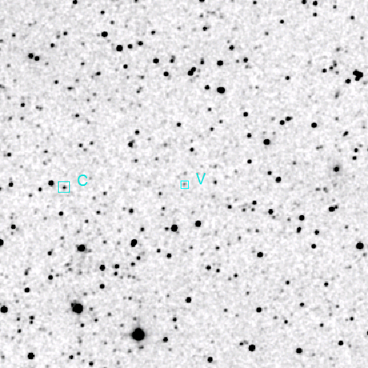

Figure 1: The new discovered variable star (V) KAO-EGYPT J231534.74+595740 and the comparison star (C) 2MASS J23155200+5957367.

**2- Data reduction**

Reduction done by using MUNIWIN (Motl, 2011) differential photometry has been done for star KAO-EGYPT J231534.74+595740.3 by using

2MASS J23155200+5957367 as comparison star.

**3- Period and time of minimum of new variable star**

The time of minimum was determined from the primary and secondary eclipses using the method of kwee and van Woerden (1956), while period of the star determined using method of Nelson (2006). Ephemeris of the new discovered variable star is shown in table 2.

Table 2: Ephemeris of new discovered variable star

|  |  |  |
| --- | --- | --- |
| Object | period(day) | Epoch(Min I) |
| V (KAO-EGYPT J231534.74+595740.3)  2MASS J23153474+5957402   |  |  | | --- | --- | | USNO-B1.0 1499-0369325 |  | | 0.32981 | 2457985.4096 ±0.0002 |

Using ephemeris from table 2 we determine the epoch of the star by eq (1), hence the phase magnitude relation has been illustrated in Fig (2). The phase magnitude table values are shown in table 3.

**HJD.(Min.I) = 2457985.4096 ±0.0002+** **0.32981 × E (1)**

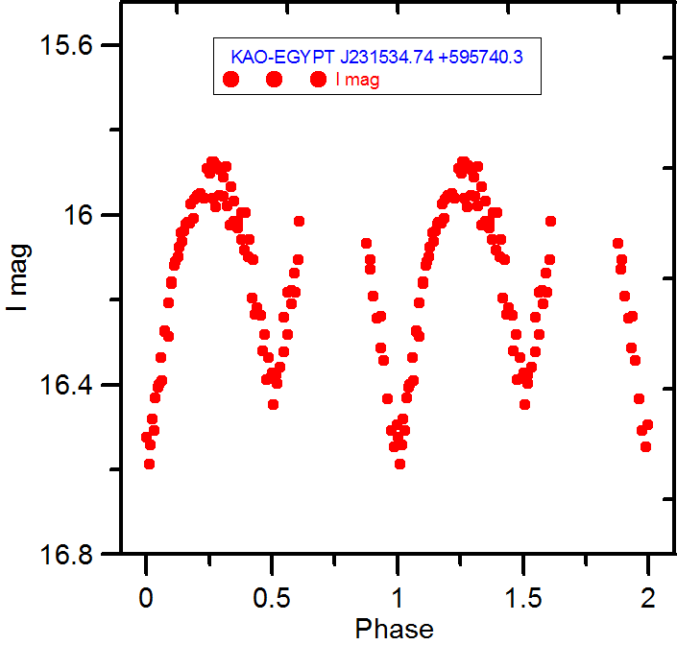

Figure 2: phase& magnitude relation for the variable star KAO-EGYPT KAO-EGYPT J231534.74+595740.3 in filter I.

Table 3 Observations of the variable star KAO-EGYPT J231534.74+595740.3 in filter I.

|  |  |
| --- | --- |
| HJD | I mag |
| 2457985.3735 | 16.1059 |
| 2457985.3873 | 16.23735 |
| 2457985.4084 | 16.49407 |
| 2457985.4126 | 16.58679 |
| 2457985.4168 | 16.48035 |
| 2457985.4210 | 16.43109 |
| 2457985.4253 | 16.39833 |
| 2457985.4295 | 16.39008 |
| 2457985.4338 | 16.27496 |
| 2457985.4380 | 16.28511 |
| 2457985.4423 | 16.15757 |
| 2457985.4465 | 16.11846 |
| 2457985.4507 | 16.09754 |
| 2457985.4549 | 16.04087 |
| 2457985.4591 | 16.03715 |
| 2457985.4634 | 16.01599 |
| 2457985.4676 | 15.97298 |
| 2457985.4718 | 15.96232 |
| 2457985.4761 | 15.95381 |
| 2457985.4803 | 15.94973 |
| 2457985.4845 | 15.95942 |
| 2457985.4887 | 15.89026 |
| 2457985.4930 | 15.90135 |
| 2457985.4972 | 15.87321 |
| 2457985.5014 | 15.88259 |
| 2457985.5056 | 15.89247 |
| 2457985.5099 | 15.91101 |
| 2457985.5147 | 15.88466 |
| 2457985.5197 | 15.93355 |
| 2457985.5247 | 15.96678 |
| 2457985.5298 | 16.01448 |
| 2457985.5348 | 15.99403 |
| 2457985.5398 | 15.99446 |
| 2457985.5448 | 16.05686 |
| 2457985.5499 | 16.10474 |
| 2457985.5549 | 16.21841 |
| 2457985.5599 | 16.23548 |
| 2457985.5650 | 16.28085 |
| 2457985.5700 | 16.33566 |
| 2457985.5751 | 16.37234 |
| 2457985.5801 | 16.3755 |
| 2457985.5851 | 16.35722 |
| 2457985.5901 | 16.32268 |
| 2457985.5952 | 16.28189 |
| 2457985.6002 | 16.20993 |
| 2457985.6052 | 16.18299 |
| 2457985.6102 | 16.01424 |
| 2457986.3575 | 16.06555 |
| 2457986.3622 | 16.12719 |
| 2457986.3668 | 16.19099 |
| 2457986.3715 | 16.24306 |
| 2457986.3761 | 16.31216 |
| 2457986.3807 | 16.34219 |
| 2457986.3854 | 16.43293 |
| 2457986.3900 | 16.50834 |
| 2457986.3947 | 16.54556 |
| 2457986.3993 | 16.5229 |
| 2457986.4040 | 16.54131 |
| 2457986.4088 | 16.50644 |
| 2457986.4134 | 16.40492 |
| 2457986.4181 | 16.33655 |
| 2457986.4227 | 16.27213 |
| 2457986.4274 | 16.20674 |
| 2457986.4321 | 16.16056 |
| 2457986.4367 | 16.10942 |
| 2457986.4414 | 16.0766 |
| 2457986.4460 | 16.06226 |
| 2457986.4507 | 16.02188 |
| 2457986.4554 | 16.01843 |
| 2457986.4601 | 16.00864 |
| 2457986.4844 | 15.87348 |
| 2457986.4858 | 15.9611 |
| 2457986.4902 | 15.98056 |
| 2457986.4949 | 15.95379 |
| 2457986.4995 | 15.95523 |
| 2457986.5042 | 15.9789 |
| 2457986.5089 | 16.02364 |
| 2457986.5135 | 16.0152 |
| 2457986.5184 | 16.0308 |
| 2457986.5231 | 16.05734 |
| 2457986.5278 | 16.08328 |
| 2457986.5325 | 16.09825 |
| 2457986.5371 | 16.19541 |
| 2457986.5418 | 16.23375 |
| 2457986.5512 | 16.32043 |
| 2457986.5560 | 16.38679 |
| 2457986.5607 | 16.38517 |
| 2457986.5654 | 16.44696 |
| 2457986.5701 | 16.39707 |
| 2457986.5794 | 16.24011 |
| 2457986.5841 | 16.18195 |
| 2457986.5888 | 16.17695 |
| 2457986.5934 | 16.13663 |
| 2457986.5981 | 16.10539 |