**STAR: GPX-TF7C-1953**  (Galactic Plane Exoplanet Survey (GPX) id#)

Discoverer(s): Paul Benni and Artem Burdanov, Galactic Plane Exoplanet Survey (GPX)

Contact: Paul Benni, 3 Concetta Circle, Acton, MA 01720; [pbenni@verizon.net](mailto:pbenni@verizon.net)

Variable type : EA

Remark : Asymetric light curve

Similar stars: V0549 CAM (VSX J052807.9+725606 ) <https://arxiv.org/ftp/arxiv/papers/1106/1106.0845.pdf>

V361 Lyr<http://adsabs.harvard.edu/full/1991AcA....41...17K>

Coordinates:

RA DEC J2000 UCAC4 : 007.1828633 +62.8503339

Other Names:

GSC 04019-02718

GSC2.3 NAM4000739

UCAC4 765-006251

2MASS J00284387+6251011

Magnitudes:

AAVSO Photometric All Sky Survey (APASS) DR9 (Henden+, 2016)

Vmag(err) 12.092 0.037

Bmag(err) 12.513 0.020

g’ mag(err) 12.271 0.030

r’ mag(err) 12.003 0.030

i’ mag(err) 11.882 0.042

B-V(err) 0.421 0.042

Rmag N/A

2MASS All-Sky Catalog of Point Sources (Cutri+ 2003)

Jmag(err) 10.986 0.022

Hmag(err) 10.799 0.030

Kmag(err) 10.612 0.026

WISE All-Sky Data Release (Cutri+ 2012)

W1mag(err) 10.486 0.024

W2mag(err) 10.372 0.021

W3mag(err) 10.159 0.318

W4mag(err) 7.643 0.097

Mag range:

Rmag (Rmin= 11.85; Rmax= 11.77)

Secondary minimum and maximum: Min II= 11.81 R. Max II= 11.79 R.

Ephemeris:

BLS_Period_1_0 = 0.61202 d

BLS_Tc_1_0 = 2457572.805

Eclipse duration 21%

Phase Plot

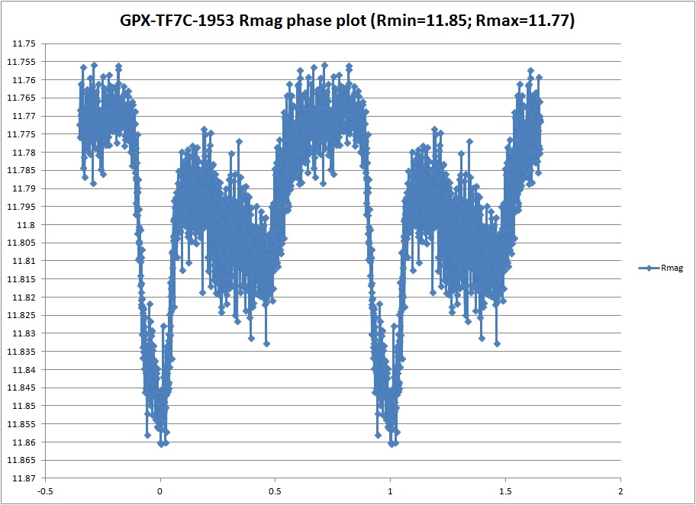

Finder chart

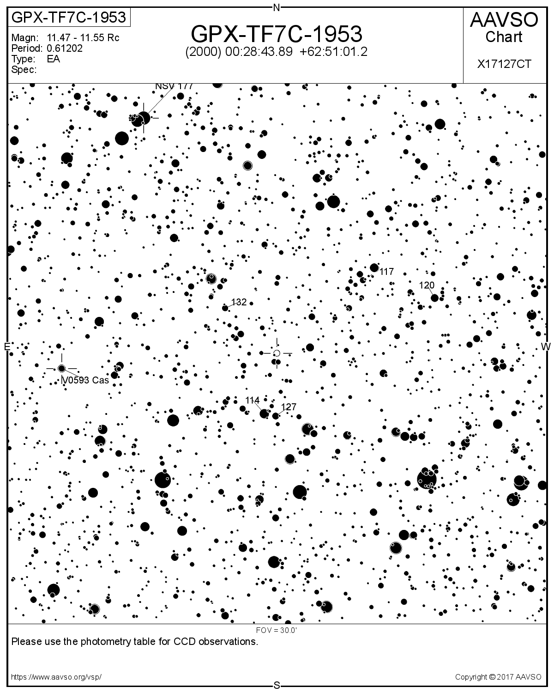

Field images showing nebula like material (Aladin)

